Samantha Pozzulo 4/24/14

Hands-on Activity Dr. Fothergill

**Barbie Bungee**

Grade: 8th

***Goals:***

-The student will make predictions and collect data using a rubber band bungee cord and a Barbie doll.  
-The student will create a scatterplot using the data that was collected to determine a line of best fit.

-The student will compare his/her predictions with the recorded data and discuss the possible variables that could influence the results.  
-The student will perform this experiment twice to explore the validity of the results.

***Objectives:***

-Given the materials necessary, the student will make predictions and record data collected during the Barbie bungee experiment.   
  
-Given the line of best fit on the scatterplots, the student will make predictions of how many rubber bands it will take for Barbie to drop 400cm, successfully.

***Standards:***

Grade 8, Stats & Probability  
  
CCSS.Math.Content.8.SP.A.1  
Construct and interpret scatter plots for bivariate measurement data to investigate patterns of association between two quantities. Describe patterns such as clustering, outliers, positive or negative association, linear association, and nonlinear association.  
  
CCSS.Math.Content.8.SP.A.2  
Know that straight lines are widely used to model relationships between two quantitative variables. For scatter plots that suggest a linear association, informally fit a straight line, and informally assess the model fit by judging the closeness of the data points to the line.  
  
CCSS.Math.Content.8.SP.A.3  
Use the equation of a linear model to solve problems in the context of bivariate measurement data, interpreting the slope and intercept. For example, in a linear model for a biology experiment, interpret a slope of 1.5 cm/hr as meaning that an additional hour of sunlight each day is associated with an additional 1.5 cm in mature plant height.

***Materials***

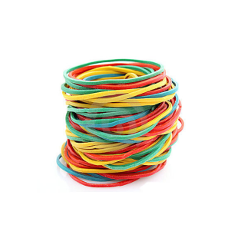

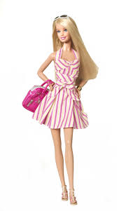

**-**Rubber Bands (Different Sizes and Types)   
-Barbie Doll  
-Measuring Tape

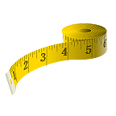

-Prediction/ Data Chart   
-Scatterplot Template  
-Questions Packet

***Introduction to the lesson: Knowledge***

Ask questions:  
-What do you know about bungee jumping?  
- Has anyone ever bungee jumped? **Bungee Jumping Video:**[**http://www.youtube.com/watch?v=zG22qQydPVQ**](http://www.youtube.com/watch?v=zG22qQydPVQ)

-Why is it not a good idea to lie about your weight and height when bungee jumping?  
-Does the length of the cord and size of the person matter when bungee jumping?

***Infer and Discuss: Comprehension***

In this lesson, we will be creating a bungee cord out of rubber bands that will safely allow Barbie to fall 200cm without getting hurt.  
 Talk with a friend:  
How many rubber bands do you think you would have to tie together for Barbie to have a safe trip?   
She must come as close to the ground as possible, without touching the floor.



***Procedure: Application***

- Create a slipknot to tie around Barbie’s feet

-Wrap the open loop around Barbie’s feet

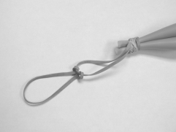

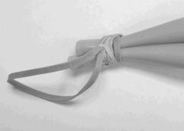

-Attach another rubber band to the one on Barbie’s feet

- Measure a height of 200cm and label it with a piece of tape.  
- Make a prediction of how many centimeters Barbie will drop with 2 rubber bands, and write it in the chart.

- One student will drop the Barbie, while the other two students observe the furthest point on the wall that Barbie reached. (Active)  
-Measure the distance fallen in centimeters for a precise answer.   
-Students will record this in their data chart next to their prediction for each trial, and then convert centimeters to inches.

- Repeat this process until Barbie has come as close as possible to the ground, without touching the floor.   
- The data chart has increments of 2 for each trial of rubber bands.  
(Make predictions and collect data for how many centimeters she fell after 2 rubber bands, 4, 6, 8, etc.)

|  |  |  |  |
| --- | --- | --- | --- |
| **Number of rubber bands** | **Prediction of Barbie’s fall**  **(Centimeters)**  **X-Variable** | **Actual distance of Barbie’s fall (Centimeters)**  **Y-Variable** | **Convert the actual distance of Barbie’s fall to inches**  **(1 inch=2.54 cm)** |
| **2** |  |  |  |
| **4** |  |  |  |
| **6** |  |  |  |
| **8** |  |  |  |
| **10** |  |  |  |
| **12** |  |  |  |
| **14** |  |  |  |

**- After completing the chart for each pair of rubber bands, the students will construct a scatterplot using the collected data (Converted to inches).**

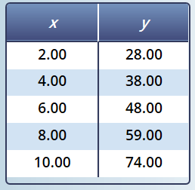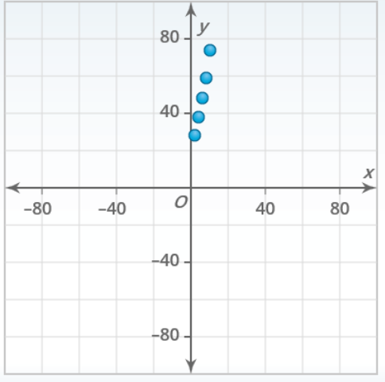

***Procedure: Analysis***

- When they have finished their scatterplot, the students will draw a line of best fit to distinguish the relationship between the number of rubber bands used and the distances Barbie dropped (In inches).

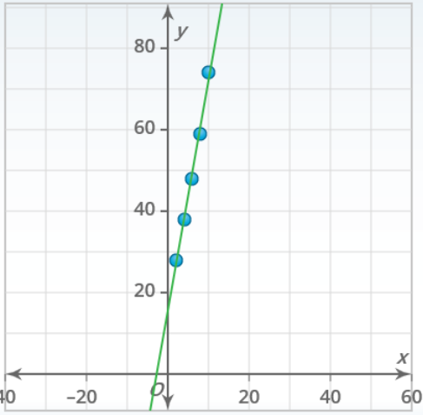

-What is the equation for your line of best fit? (Convert to inches)  
<http://illuminations.nctm.org/Activity.aspx?id=4186>

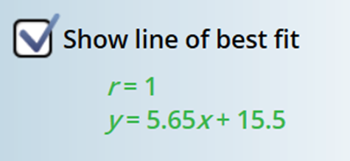

-What is the slope of your equation, and what does it represent in this context?

(Slope- # of rubber bands increases by two)

-What is the *y*-intercept of your equation, and what does it represent in this context?  
 ?(x=0)?

***Results: Synthesis***

-Based on your data, what would you predict is the maximum number of rubber bands Barbie needs to safely jump 400 cm?  
  
Using your Line of Best Fit: ________________________________  
Are your predictions reliable? Justify your answer. Be sure to consider your methods of collecting, recording, and plotting data.

- What variables impacted the results of this experiment?  
  
- How would you improve this experiment?  
  
- What can we do to make this a more reliable experiment?   
(Rubber band size)

***Next Steps: Evaluation***

- The students will conduct the experiment again, record their findings, and compare/contrast these results with the results from the previous trial.  
  
- Did the data change? Did the distance fluctuate for each pair of rubber bands?  
  
- Is this an accurate and valid experiment?  
  
- What are the flaws of this activity?

**Conclusion**

As the number of rubber bands increase, so does the distance that Barbie drops.  
  
The students should realize that the different: rubber bands, Barbie dolls, observers, and releasers can alter the results for this experiment.   
  
The students predicted, observed, and recorded data to investigate different variables and their dependency.

***Resources***

-Zordak, Samuel E. "Barbie Bungee." *Barbie Bungee*. NCTM, n.d. Web. 29 Apr. 2014.  
  
Direct Link:[**http://illuminations.nctm.org/Lesson.aspx?id=2157**](http://illuminations.nctm.org/Lesson.aspx?id=2157)