GeoGebra Lesson: Finding the sum of interior angles within a triangle.
Grades: 6-10
Interior Angles: In a triangle, all three angles will have a sum of 180°. There can only be one angle that is greater than 90°, creating an obtuse triangle. In a right triangle, one angle will have a measure of exactly 90°, which means that the other two angles must add to 90°.
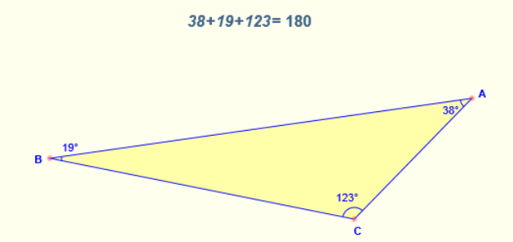

Let’s practice different ways to evaluate the sum of interior angles using GeoGebra:
1) Click on the polygon button and draw any triangle.
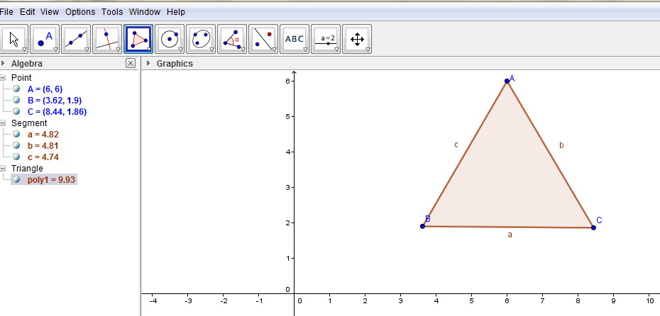
- We can use the object properties to hide line segments (a,b,c).
- Right Click, Select: Object Properties, Unclick “Show Label”

2) Click the Angle button, find the measure of each angle.
- The angles must be drawn in a specific direction. For example:
- For example: To find the measure of angle A, click B, A, C
- To find the measure of angle B, click C, B, A
- To find measure of angle C, click A, C, B
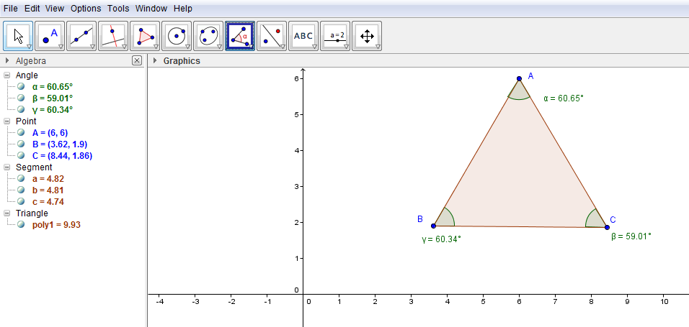
3) Find the midpoints of segment AB and AC
- Click on midpoint button
- Click A and then B to find the midpoint, (Labeled D)
-Click A and then C to find the midpoint, (Labeled E)
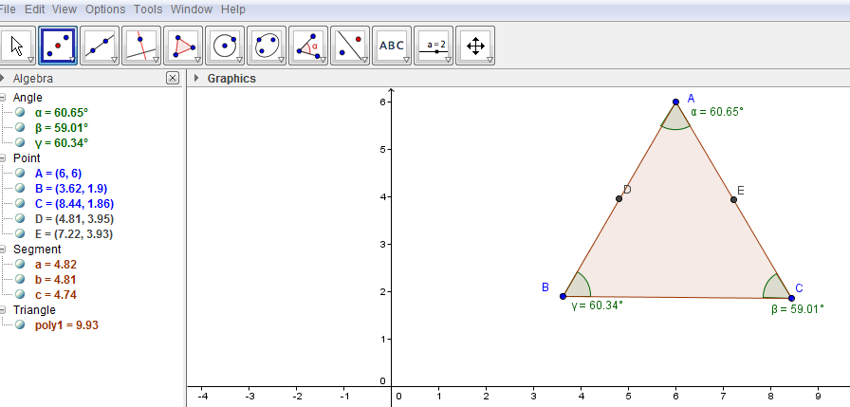4a) Create sliders
Click on Angle in the box, change the Max to 180°, and select apply 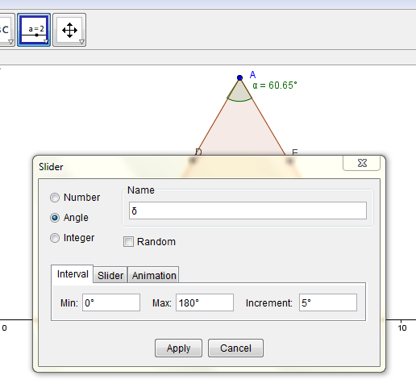
4b) Create another slider, using the same alterations (Click angle, max 180°, apply)
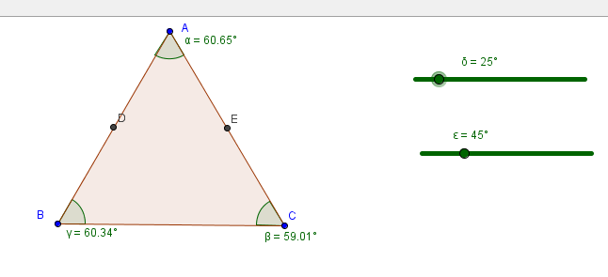
5a) Click on rotate around a point, then click on triangle ABC. Select point D:
- Change (45° to the symbol on the first slider, leave counter clockwise, hit ok)
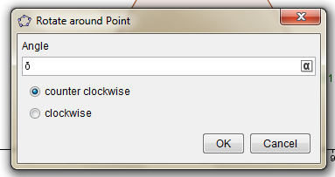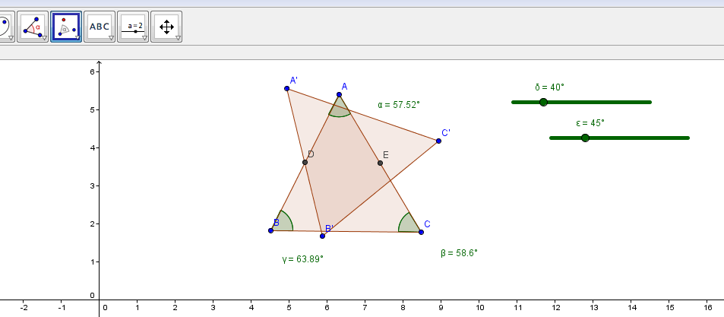

5b) Click on rotate around a point, then click on triangle ABC. Select point E:
- Change( 45° to the symbol on the second slider, click clockwise, hit ok)
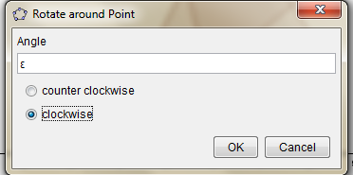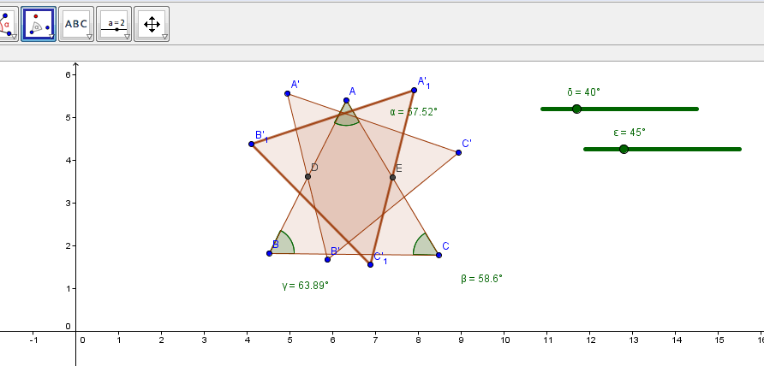

6) Manipulate the sliders, have all three triangles create a straight line.
- Move around the labels so that the image is more organized.
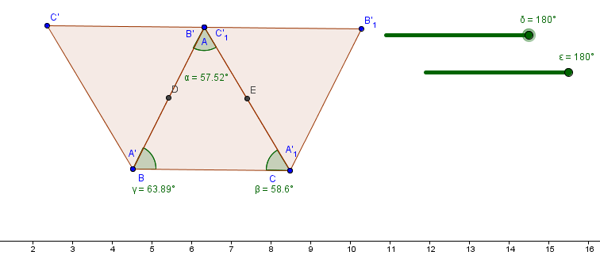

- What do we know about the measure of straight lines? ______________________________
- What does this have in common with interior angles of triangles? ______________________
- When we manipulate the triangles, what do we see? ____________________________________________________________________________
- Why do you think it is important for students to see this possibility? ____________________________________________________________________________

7) Clean up the picture by hiding the unnecessary labels. Only keep the labels- A: B’ : C’₁
- This includes removing the midpoint labels
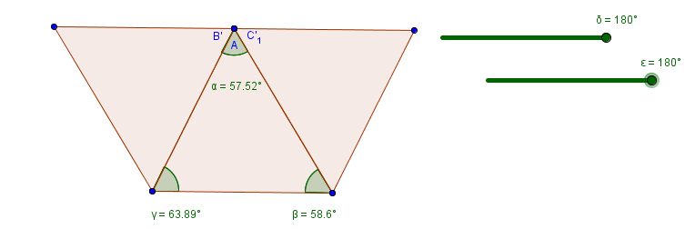

8) Insert textbox to state the sum of interior angles, click ok.
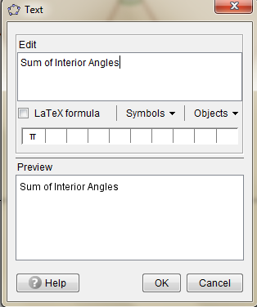

9) Type information into the input bar, using the appropriate symbols, click enter.

10) Create another textbox, Sum = (the symbol for the sum we just wrote)
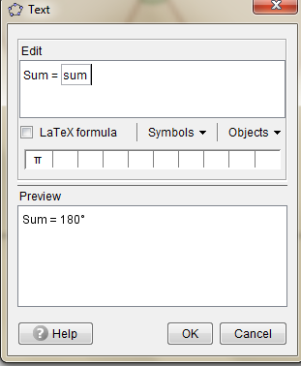

11) Final Solution:
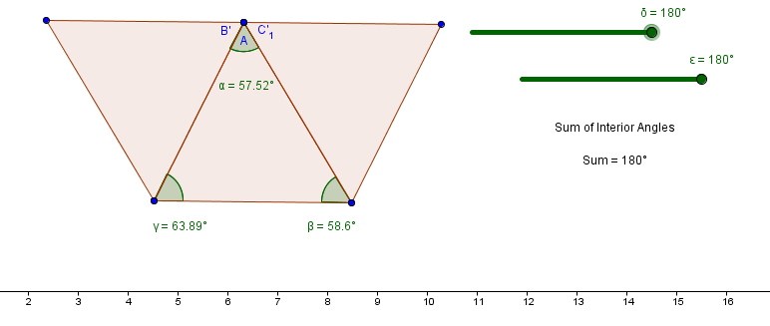

GeoGebra Lesson: Exterior Angles

Grades: 6-10

An exterior angle of a triangle is equal to the sum of the two opposite interior angles.
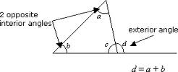
Let’s prove this to be true, using GeoGebra.
1) Click on the polygon button and draw any triangle.
- We can use the object properties to hide line segments (a,b,c).
- Right Click, Select: Object Properties, Unclick “Show Label”
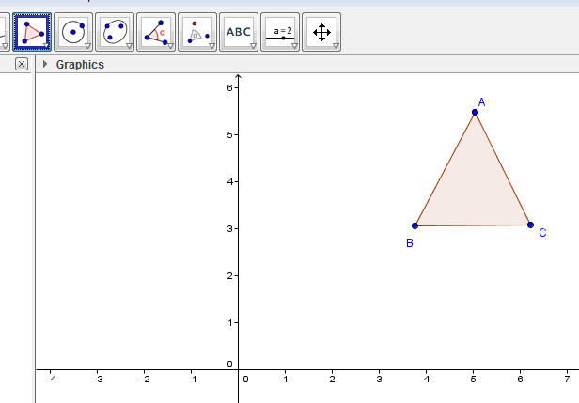
2) Draw a line through points, B and C
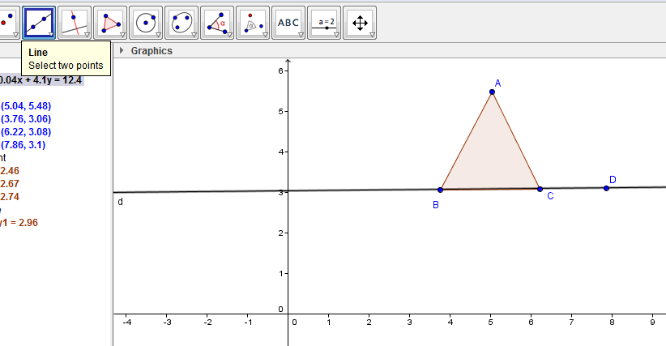

3) Measure the three interior angles of triangle ABC. To find angle A, click BAC. To find angle B, click CBA. To find the angle C, click ACB.
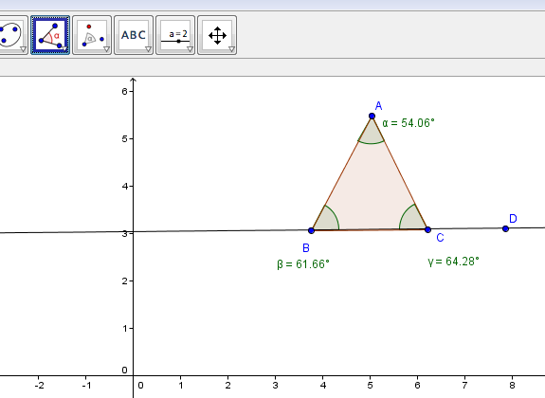

4) Type 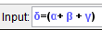 into the input bar. Be sure to use the symbols in the bottom right hand corner.

5) Select the text box and type: ( Use the objects drop down menu to find the symbols)
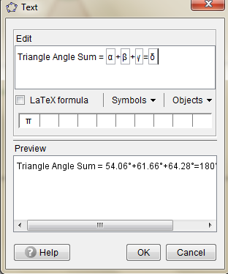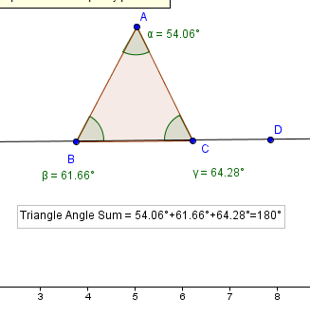

6) Find angle ACD. To find the exterior angle you must click D first, then C, and A.
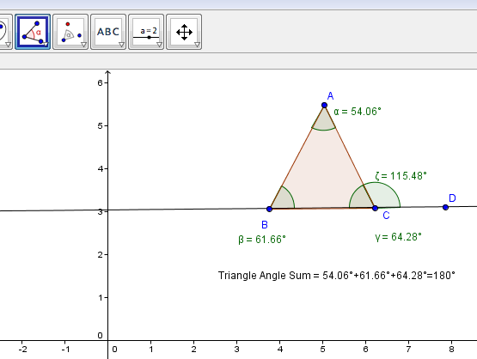

7) Change the color of angle ACD to help see the difference. Select Object properties and choose a color. Select the text box button and fill in the following information. Use the objects drop down box to select the symbols.

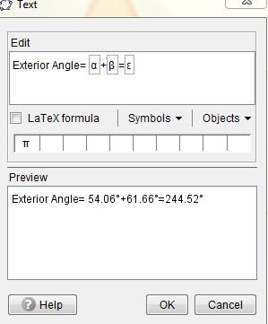
This step shows us that the exterior angle equals the sum of the two opposite interior angles.

8) Final Product
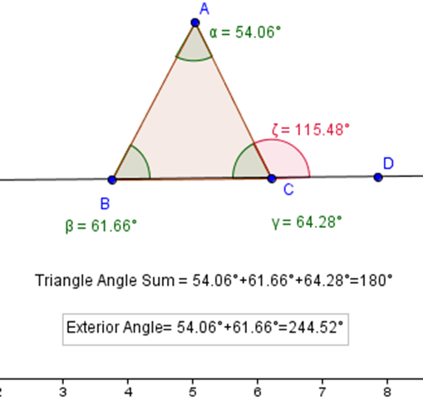

- How else can the measure of the exterior angle be found? _________________________________________________________________________
- Is this true for every triangle? _______________________

I found my ideas from different Youtube videos.
http://www.youtube.com/watch?v=hrdjU7jkZhI ( Interior Angles)
http://www.youtube.com/watch?v=m5nfWOcgQ5o ( Exterior Angles)

