Problem: A group of friends decide to meet for pizza, and one friend calls ahead to order the pies. However, three people in the group do not show up at the pizza parlor. The friends who do show up figure that they each add $3 to their original share, to cover the bill, which totals $70. How many friends eat pizza?
Consider:
- We know the total they paid for the pizza is $70.
- How would you decide with your friends how much you should pay for pizza if this was you?!
- What would you do if one of them didn't show up? Two of them? Three of them?
Hint 2:
(# of people expected) x ($ per person) = $70?
Think about who actually shows up. How would you figure out the amount per person if everyone showed up?
Solution:
How to set up the equation:
Let f= the number of friends expected to eat pizza.
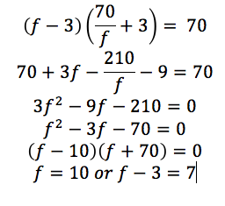
Another Solution:
Let f = the number of friends expected to eat pizza.
The only possible values for f and f - 3 must be divisors of 70 (1, 2, 5, 7, 10, 14, 35, and 70).
The only two numbers in the set that differ by 3 in the divisors are 7 and 10.

